

**Student ID:** 23182

**Course code:** INSY413

**Course** **name**: Web Technology and Internet

topic: Police management System

web TECHNOLOGY AND internet final exam project

December 18, 2023

**Ntakirutimana Zion**

**AUCA: ADVENTIST university of central africa**

Table of Contents

Police management system 4

1. Introduction 4

1.2 Ambition 5

Efficiency and Promptness: 5

Precision and Data Trustworthiness: 5

Uniformity and Stability: 5

Privacy and Confidentiality: 5

Integration and Interoperability: 5

Accessibility and Inclusivity: 5

Transparency and Accountability: 5

Continuous Improvement and Feedback Mechanisms: 6

Training and Support Infrastructure: 6

1.3 Scope of the system 6

1.4 Police Management system Screenshots 7

*Figure 1: Home Screen* 7

*Figure 2: Admin Signup page* 8

*Figure 3: Admin able to manipulate all data* 9

*Figure 4: Admin****’***s *when uploading files* 10

*Figure 5: Admin views the all data Registered* 11

*Figure 6: Admin’s updating Police or user* 12

*Figure 7: Police or user updated* 13

*Figure 8: Admin’s searching any User or Police by email* 14

*Figure 9: Admin’s searching Unknown User by email* 15

*Figure 10: Result after Admin’s searching Unknown Police by email* 16

*Figure 11: User Create Account* 17

*Figure 12: User create account successfully* 18

*Figure 13: User Login* 19

*Figure 14.1: User Loggedin and fill the form* 20

*Figure 14.2: User Loggedin and fill the form* 21

*Figure 15: User submitting success an application* 22

*Figure 16: User already has been created an account* 23

1.5 Deployment link of Police Management system 24

*1.5.1 Link:* 24

1.6 Conclusion 24

# 

# Police management system

## 1. Introduction

A Police management system represents a sophisticated software infrastructure meticulously crafted to streamline and automate the intricate procedure of enrolling individuals aspiring to become part of the Police or a Police service. Its fundamental purpose lies in acting as a centralized and comprehensive platform meticulously tailored to expedite and manage the entire spectrum of the registration process, seamlessly guiding candidates from their initial application stages through to eventual enrollment.

This specialized software solution operates as a sophisticated hub, orchestrating and optimizing every facet of the candidate registration journey. It harnesses cutting-edge technologies and innovative functionalities to not only simplify but also enhance the efficacy and transparency of the enrollment process. By offering a centralized repository for applicant information, it ensures a cohesive and structured approach to data management, meticulously organizing and securely storing essential details crucial for evaluation and enrollment.

Moreover, beyond mere digitization, this system serves as an intelligent coordinator, employing automation to alleviate administrative burdens, minimize redundancies, and significantly expedite the progression from application submission to the final stages of enrollment. Its seamless integration of various stages, coupled with robust security protocols, safeguards sensitive applicant data, ensuring confidentiality and trust throughout the entire process.

Furthermore, this system is meticulously designed to be user-friendly, providing intuitive interfaces and comprehensive support mechanisms to guide applicants through each step of their registration journey. Its scalability and adaptability empower it to align with evolving regulatory frameworks and technological advancements, ensuring it remains a cutting-edge solution facilitating the crucial process of candidate registration within law enforcement agencies.

## 1.2 Ambition

**Efficiency and Promptness:** The system aims to hasten the registration process by reducing reliance on paperwork, implementing automated data capture, and eradicating manual discrepancies. Its goal is to enable applicants to swiftly and seamlessly complete registration.

**Precision and Data Trustworthiness:** The objective is to uphold precise and dependable records of applicant details. The system endeavors to authenticate and validate the credibility of submitted documents and credentials to ensure the veracity of the registration process.

**Uniformity and Stability:** The aim is to establish consistent methodologies and benchmarks for registration across diverse army branches or geographic regions. This guarantees that all candidates undergo evaluation and processing based on equitable criteria, fostering fairness and parity.

**Privacy and Confidentiality:** The system aims to safeguard the confidentiality and security of applicant information. It strives to employ robust protective measures to shield personal and sensitive data, preventing unauthorized access or breaches from occurring.

**Integration and Interoperability:** The system aims to seamlessly integrate with existing law enforcement databases and systems, ensuring smooth data exchange and interoperability. This integration enhances collaboration among different agencies and promotes a holistic view of applicant information, avoiding redundancies and facilitating informed decision-making.

**Accessibility and Inclusivity:** The system prioritizes accessibility for applicants from diverse backgrounds, ensuring that the registration process accommodates various languages, disabilities, and technological capabilities. This inclusivity fosters a welcoming environment, allowing all qualified individuals equal opportunity to apply and be considered for enrollment.

Transparency and Accountability: The system incorporates features that promote transparency throughout the registration journey, providing applicants with clear insights into the process stages and timelines. Moreover, it includes audit trails and accountability mechanisms to track actions taken within the system, ensuring compliance with established protocols and regulations.

**Scalability and Future-Readiness:** With an eye towards the future, the system is designed to be scalable, accommodating potential increases in applicant volume and evolving technological landscapes. It anticipates and adapts to future needs, enabling seamless upgrades and expansions without compromising efficiency or functionality.

**Continuous Improvement and Feedback Mechanisms:** Embracing a culture of continuous enhancement, the system encourages feedback loops from applicants and administrators. It incorporates mechanisms to gather suggestions and insights, allowing for iterative improvements that enhance user experience and system efficacy over time.

**Training and Support Infrastructure:** Recognizing the importance of user proficiency, the system includes comprehensive training modules and support structures for both applicants and administrators. This ensures that all stakeholders are equipped with the necessary knowledge and resources to navigate the system efficiently.

By incorporating these additional scopes, the Police Management System can evolve into a robust and inclusive platform, fostering efficiency, fairness, and transparency throughout the applicant registration and enrollment process.

# 1.3 Scope of the system

The Police management System ensures the efficient and standardized handling of applicant information across different regions or branches of the army.

**2.** It prioritizes accuracy and data integrity to maintain reliable records of applicant

**3.** Details and validate the authenticity of submitted documents.

**4.** The system aims to enhance the overall applicant experience by simplifying the registration process, providing clear instructions, and offering support throughout the various stages of registration.

**5.** Security and confidentiality of applicant data are paramount, with robust

Measures in place to protect personal and sensitive information from unauthorized access or breaches

**6.** The ambition of the Police Registration System is to contribute to the effectiveness of Police recruitment efforts by efficiently registering and enlisting qualified individuals for appropriate army roles.

# 1.4 **Police Management system** Screenshots

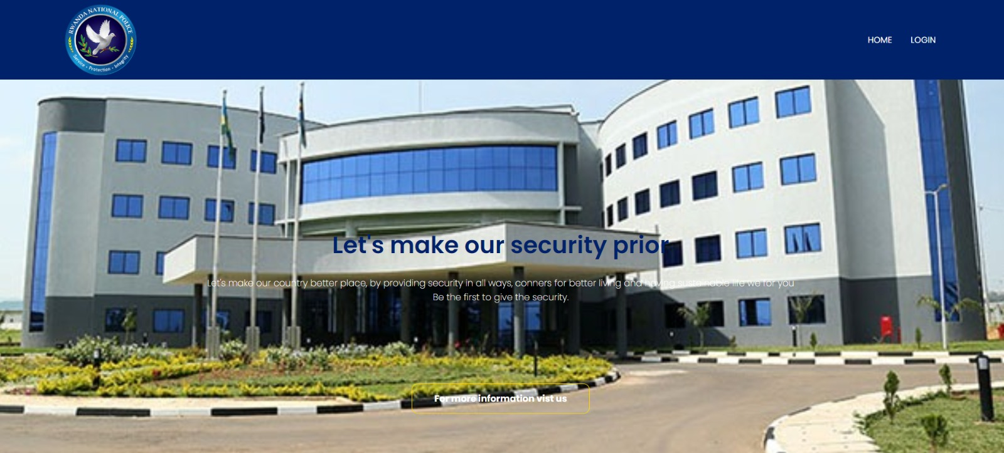

### *Figure 1: Home Screen*

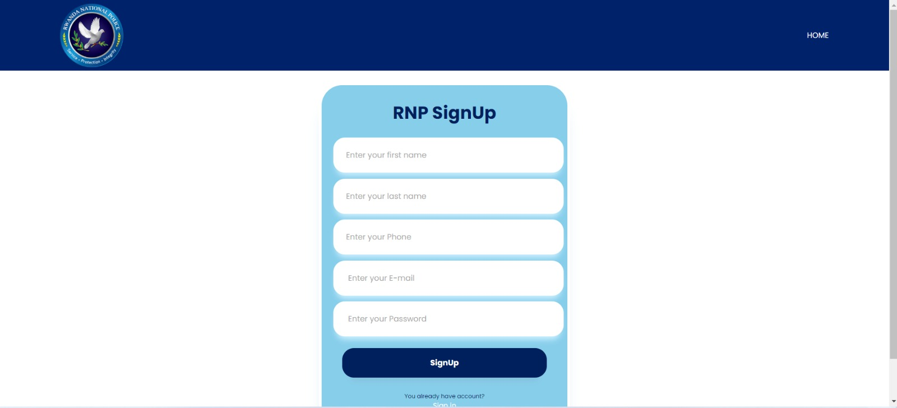

### *Figure 2: Admin Signup page*

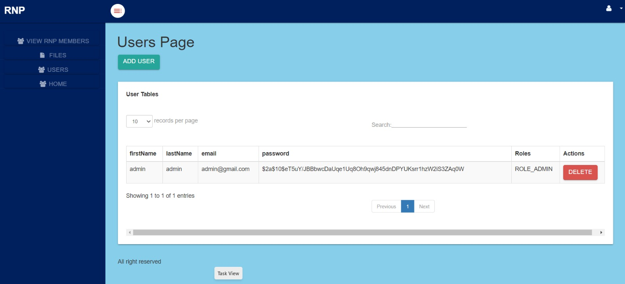

### *Figure 3: Admin able to manipulate all data*

## 

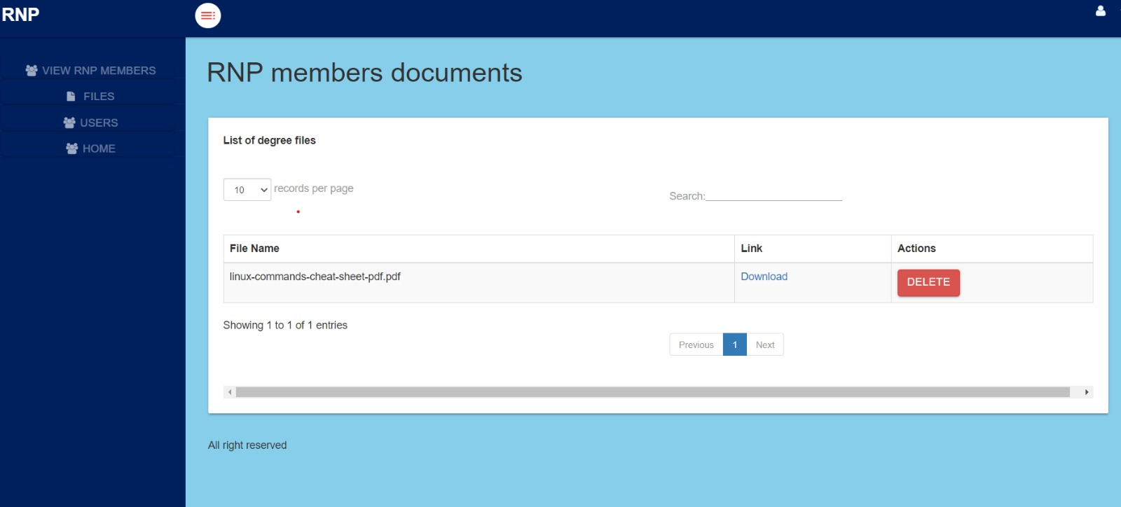

### *Figure 4: Admin****’***s *when uploading files*

### *C:\Users\HP\Desktop\AllSave\policePage\AdminViewAlldata.PNG*

### *Figure 5: Admin views the all data Registered*

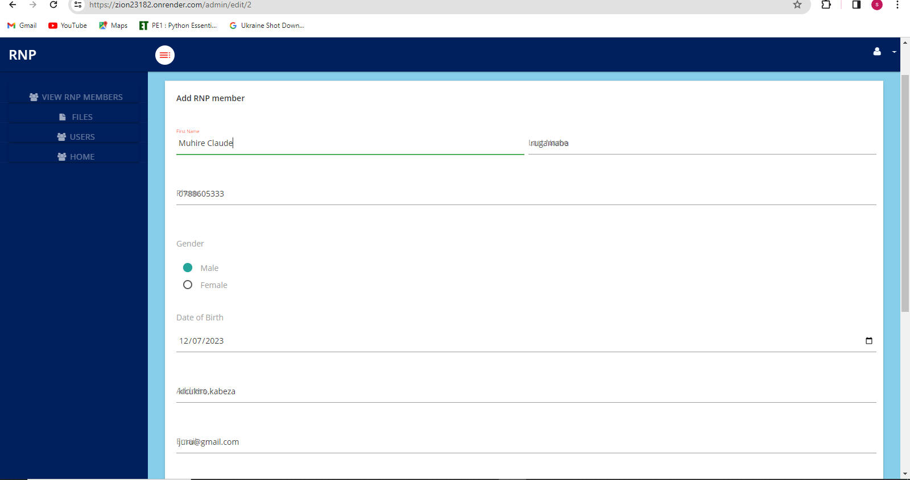

### *Figure 6: Admin’s updating Police or user*

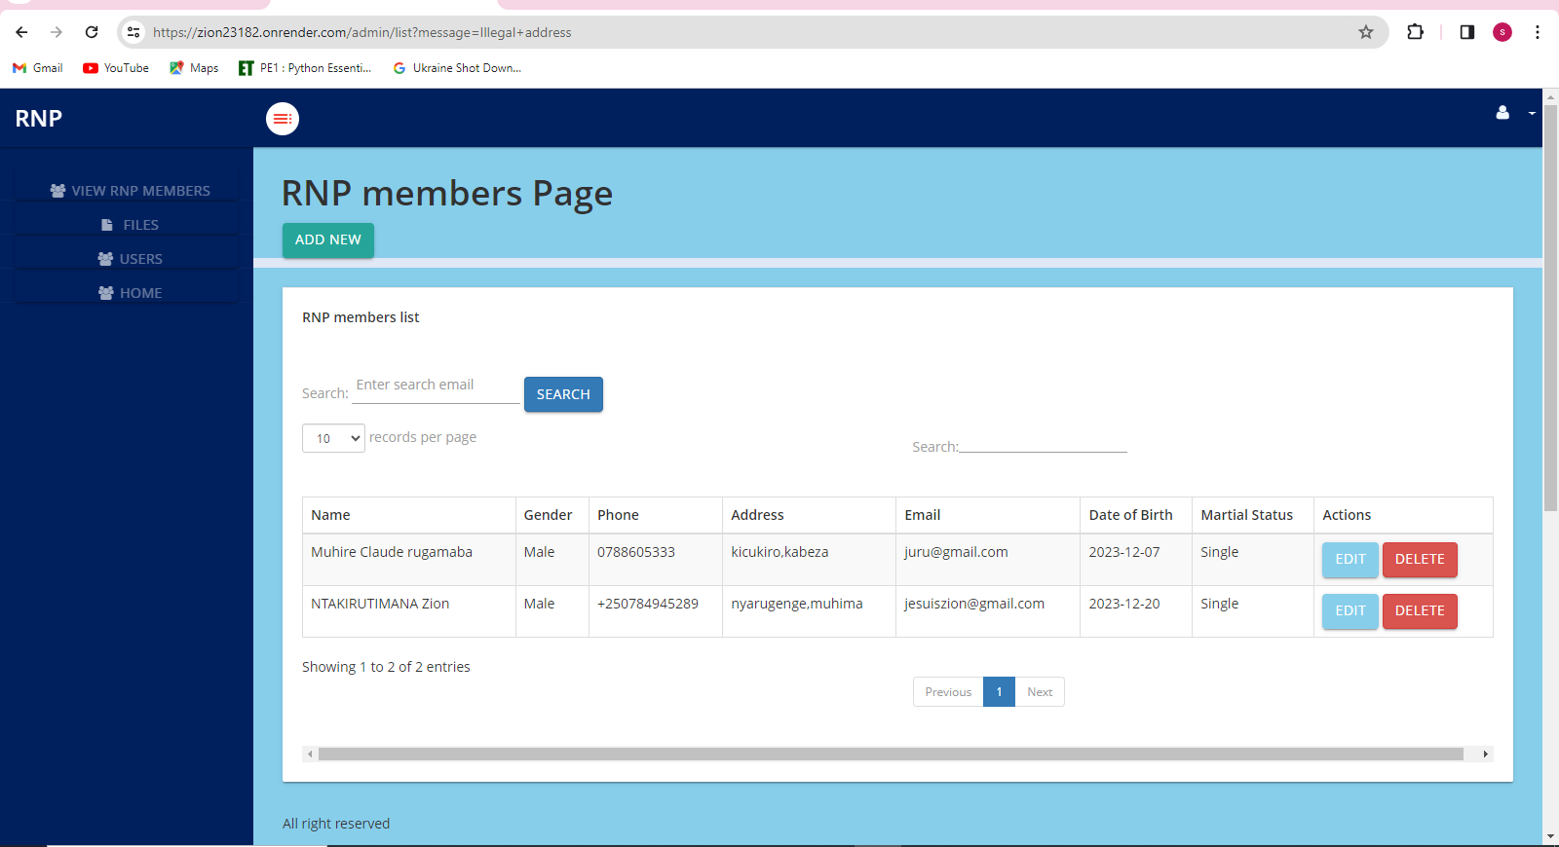

### *Figure 7: Police or user updated*

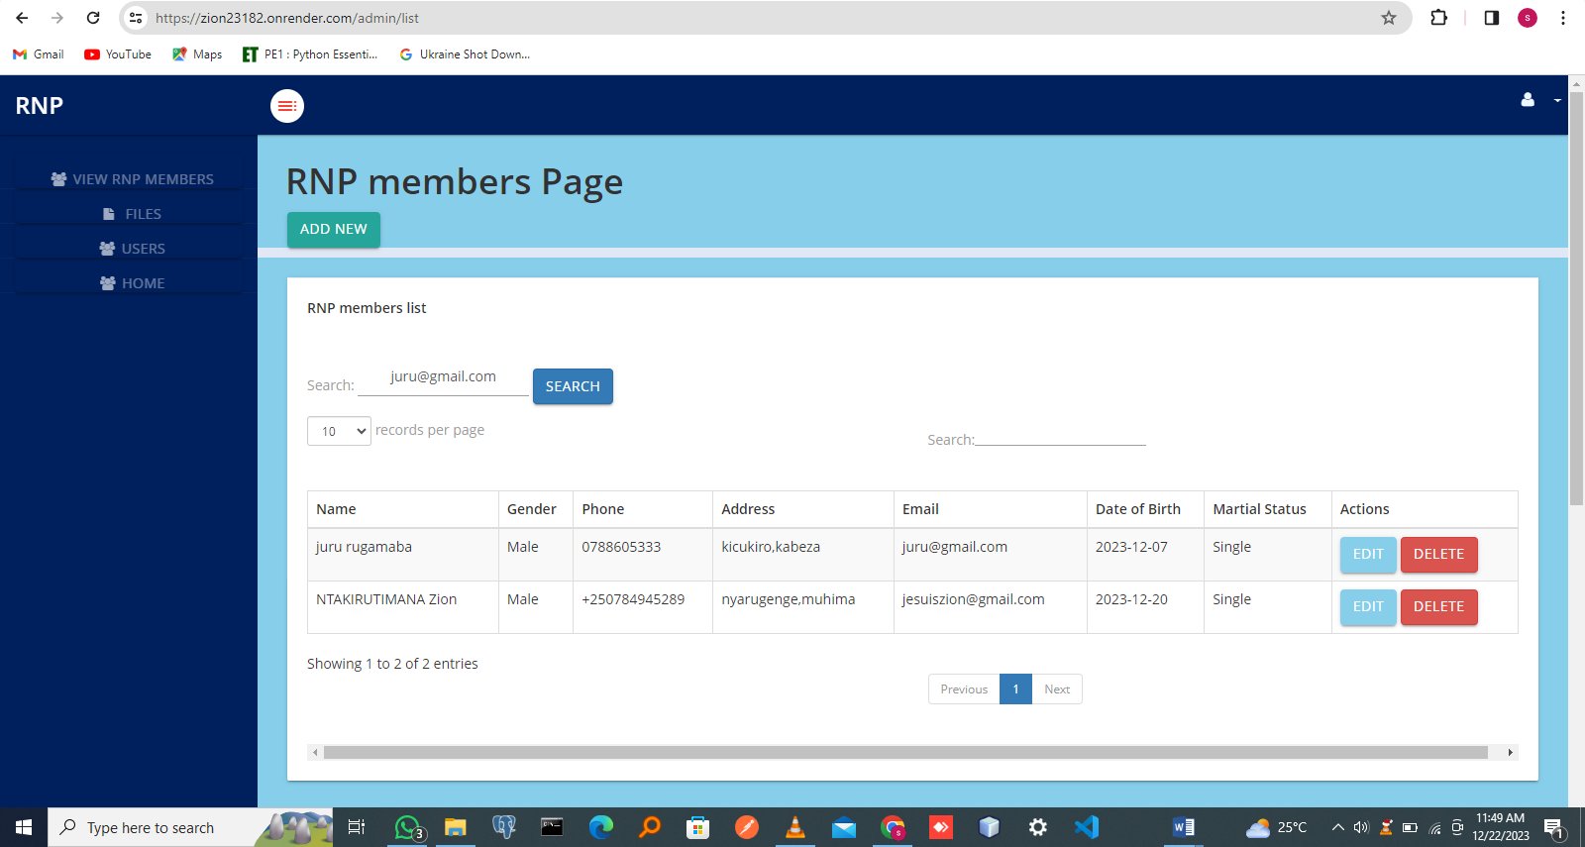

### *Figure 8: Admin’s searching any User or Police by email*

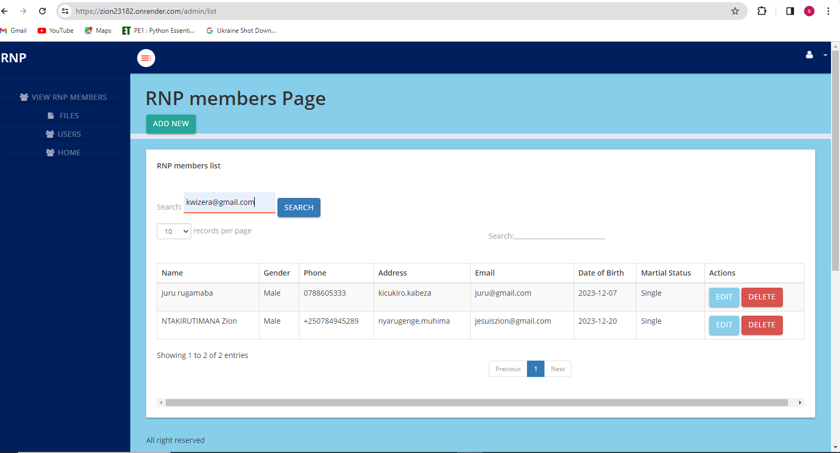

### *Figure 9: Admin’s searching Unknown User by email*

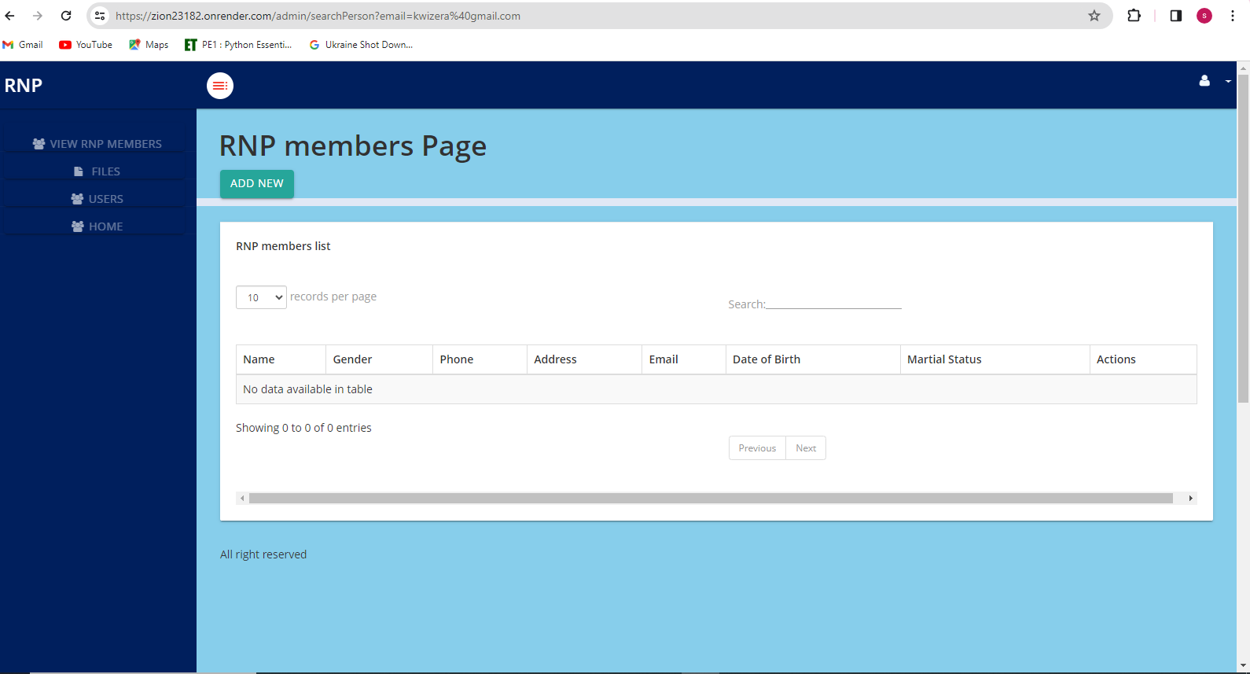

### *Figure 10: Result after Admin’s searching Unknown Police by email*

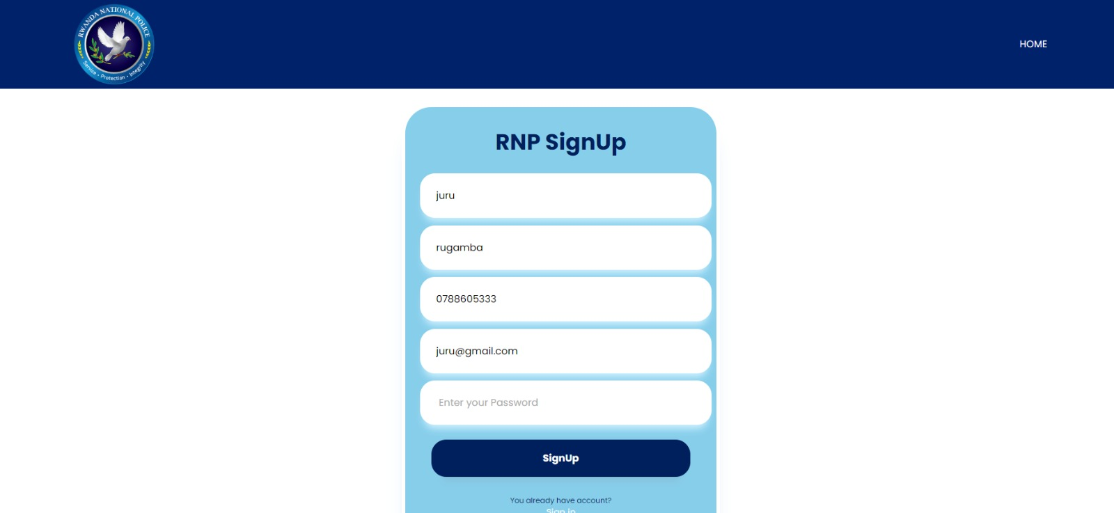

### *Figure 11: User Create Account*



### *Figure 12: User create account successfully*

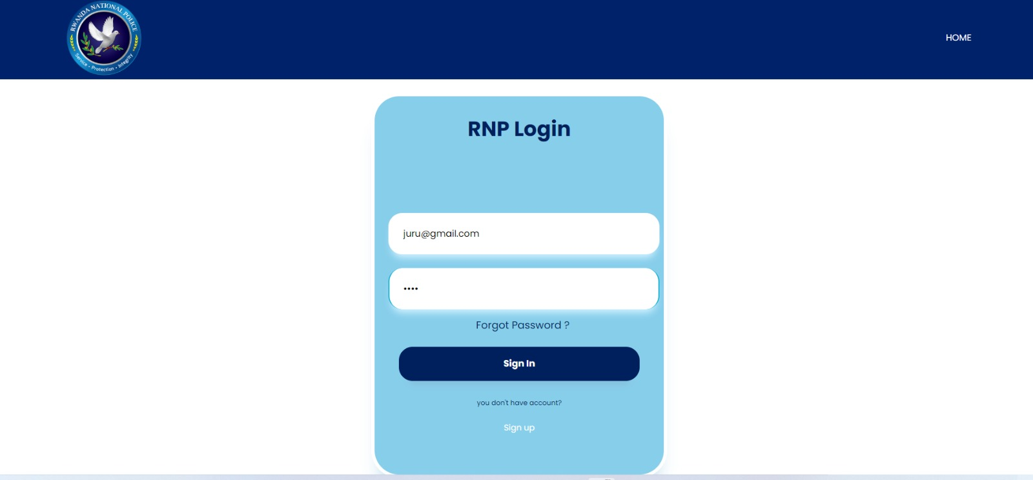

### *Figure 13: User Login*

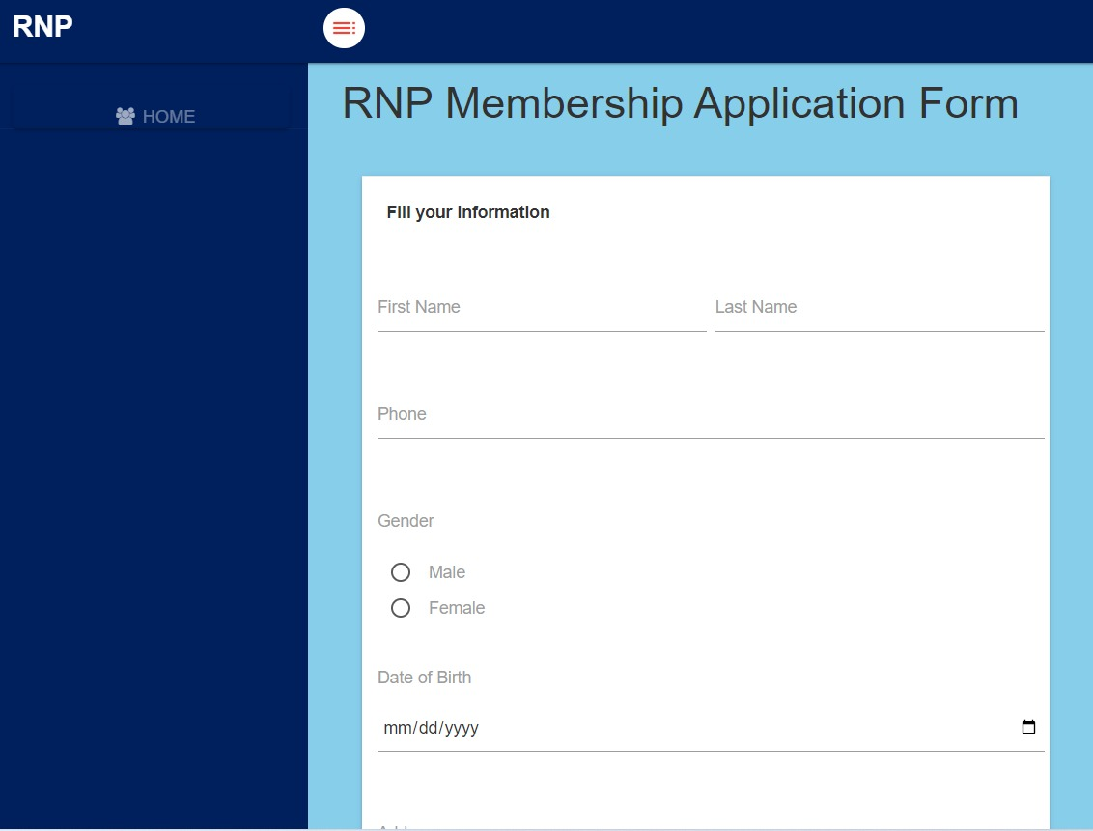

### *Figure 14.1: User Loggedin and fill the form*

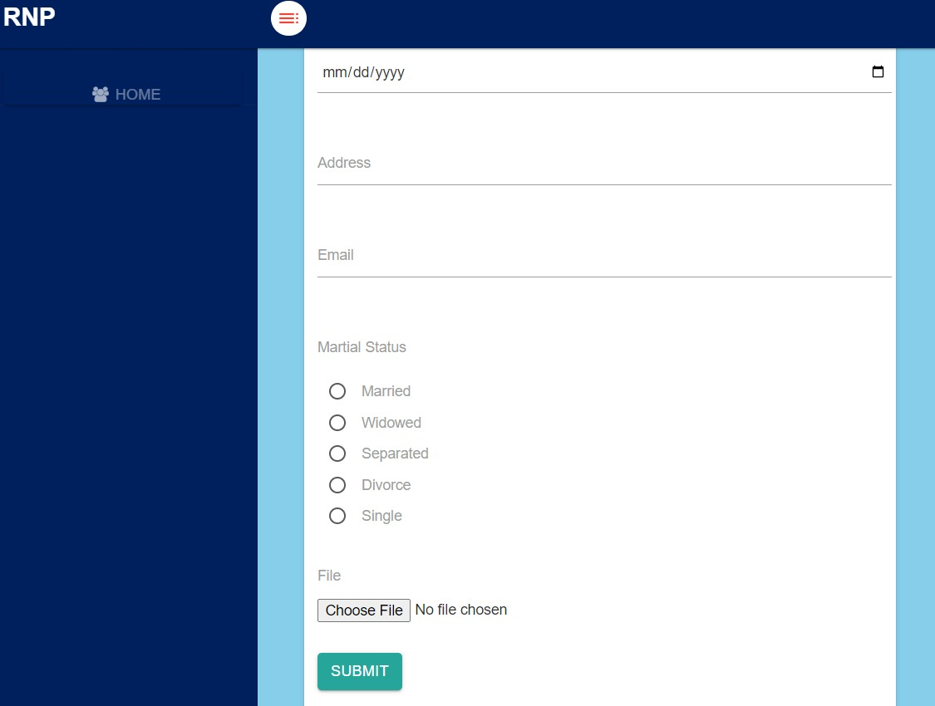

### *Figure 14.2: User Loggedin and fill the form*



### *Figure 15: User submitting success an application*



### *Figure 16: User already has been created an account*

# 1.5 Deployment link **of Police Management system**

*1.5.1 Link:* https://zion23182.onrender.com

# 1.6 Conclusion

The effective management of the Rwanda Police necessitates a comprehensive approach that encompasses multifaceted strategies. This entails a dedicated focus on leadership training, the infusion of modernized equipment, and the cultivation of a culture deeply rooted in accountability. To further augment operational efficiency, it is imperative to institute transparent communication channels and empower officers through robust educational initiatives and skill development programs.

Moreover, the sustainability and advancement of the Police framework rely significantly on fortifying civil-military relations and embedding human rights education within the core of Police operations. These elements serve as foundational pillars for enduring growth and resilience. Furthermore, nurturing collaborative partnerships within the region for strategic cooperation amplifies the Police's effectiveness while instilling a profound sense of national identity among the force.